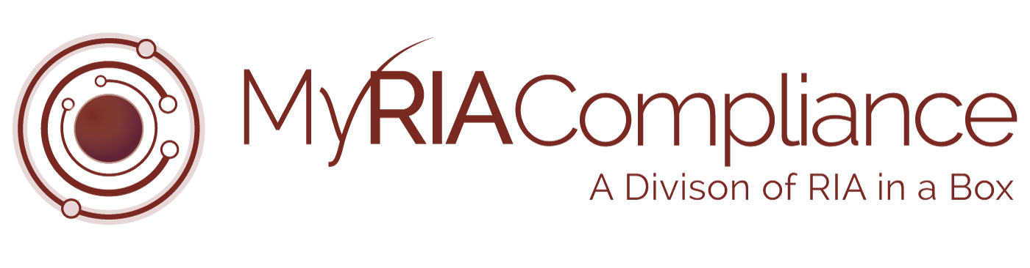

*The following document is provided to You as a sample only.  Prior to using or implementing this document or any portion thereof, You should tailor the contents, including any highlighted sections, to fit your specific situation and should consult relevant regulatory authorities and/or legal counsel. RIA in a Box and its compliance division (“We”) do not represent or warrant that the contents of the document are suitable for You from a compliance, regulatory, legal, or any other perspective. We shall have no responsibility or liability for your use or non-use of the document or any portion thereof. We are not law firms, investment advisory firms, or CPA firms and do not provide legal advice or opinions.* ***Please note that reference to “RIA Name” should be changed to reference your firm name or the firm’s abbreviation used in other portions of your compliance manual.***

Copyright © 2018 RIA in a Box LLC

# **Disclosure**

**WARRANTIES & DISCLAIMERS**

There are no warranties implied.

RIA Firm Name is a registered investment adviser located in [insert city and state]. RIA Firm Name may only transact business in those states in which it is registered, or qualifies for an exemption or exclusion from registration requirements. RIA Firm Name’s web site is limited to the dissemination of general information pertaining to its advisory services, together with access to additional investment-related information, publications, and links. Accordingly, the publication of RIA Firm Name’s web site on the Internet should not be construed by any consumer and/or prospective client as RIA Firm Name’s solicitation to effect, or attempt to effect transactions in securities, or the rendering of personalized investment advice for compensation, over the Internet. Any subsequent, direct communication by RIA Firm Name with a prospective client shall be conducted by a representative that is either registered or qualifies for an exemption or exclusion from registration in the state where the prospective client resides. For information pertaining to the registration status of RIA Firm Name, please contact the state securities regulators for those states in which RIA Firm Name maintains a registration filing. A copy of RIA Firm Name’s current written disclosure statement discussing RIA Firm Name’s business operations, services, and fees is available at the SEC’s investment adviser public information website – [www.adviserinfo.sec.gov](http://www.adviserinfo.sec.gov) or from RIA Firm Name upon written request. RIA Firm Name does not make any representations or warranties as to the accuracy, timeliness, suitability, completeness, or relevance of any information prepared by any unaffiliated third party, whether linked to RIA Firm Name’s web site or incorporated herein, and takes no responsibility therefor. All such information is provided solely for convenience purposes only and all users thereof should be guided accordingly.

This website and information are provided for guidance and information purposes only. Investments involve risk and unless otherwise stated, are not guaranteed. Be sure to first consult with a qualified financial adviser and/or tax professional before implementing any strategy. This website and information are not intended to provide investment, tax, or legal advice.

[OPTIONAL] Insurance products and services are offered and sold through [insurance firm name] and individually licensed and appointed insurance agents.